IMPLEMENTING CRM FOR RESULT TRACKING OF A CANDIDATE WITH INTE RNAL MARKS

# INTRODUTION

## overview

Define yourrequirements: first .you need to define your requirements for the CRM System .what information do you need to track about the candidate? Will the system need to be integrated with other systems such as a student information systems a grading system?

Choose u CRM System: once you have defined your requirements. You can choose a CRM system that meets those requirements .there are many CRM system available. Includingopen Source options the suite CRM and commercial options like salesforce. Consider factors such as cost. Case of use. and the availability of features you need.

# purpose

Define the objectives: the first step to define the objectives of the CRM system. What are the specific goals you want to achieve? Do you want to improve the tracking of internal marks for candidates? Do you want identify areas where candidates are struggling? Do you want to provide better support and communication to candidates?

Choose a CRM platform: Next, you need to choose a CRM platform that will work best for your needs. There are many options available. Including salesforce. HubSpot. Zcho, and others. Consider factors like cost,case of use scalabillty. and features when choosing a platform.

# 2.PROBLEM DEFINITION & DESIGN THINKING

# 2.1 Empathy Map

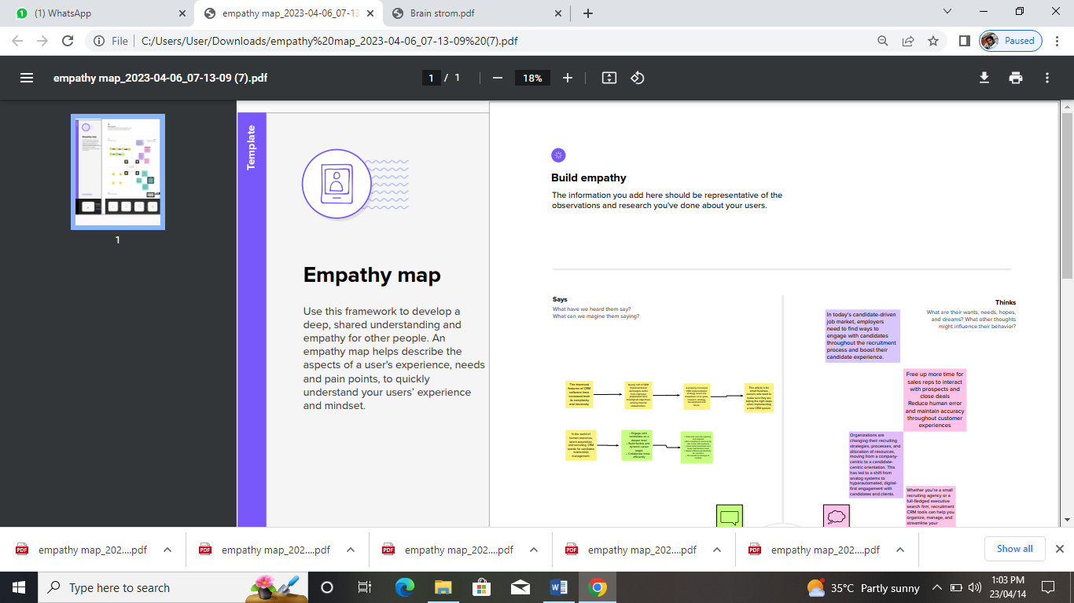

## 2.2 Ideation & Brainstorming Map

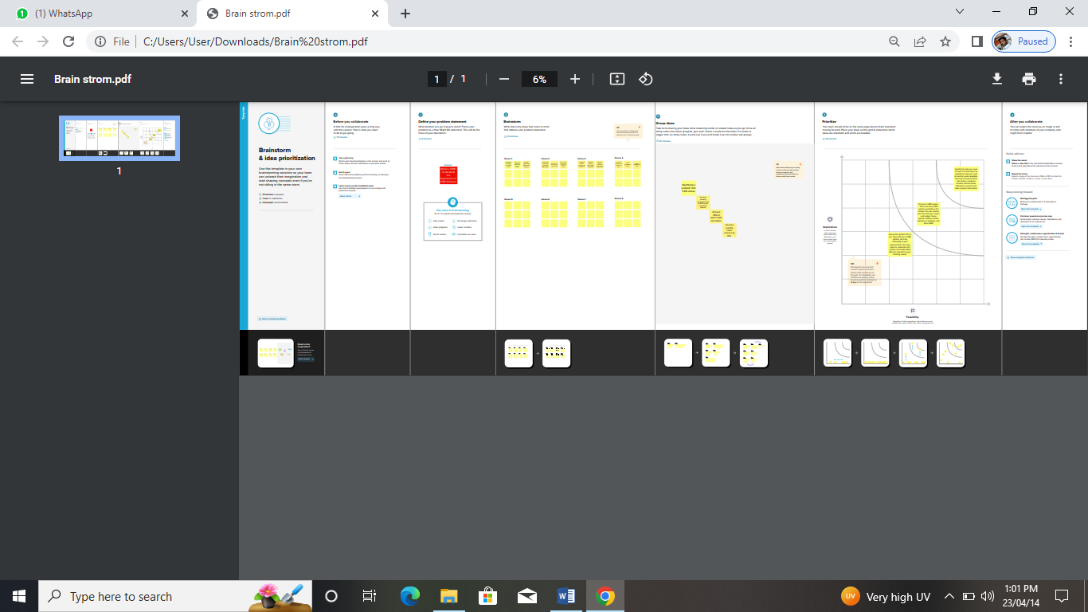

# 3. RESULT

# 3.1 Data Model :

|  |  |  |
| --- | --- | --- |
| **Object Name** | **Fields in the object** | |
|  | **Field label** | **Data type** |
| **Candidate** | Semester Name | Text |
| Candidate ID | Text |
| Candidate Name | Text |
| **Course Detail** | Course Name | Text |
| **Internal Result** | Internal Result Name | Text |
| **Lecturer Details** | Lecture Name | Text |
| Lecture Role | Text |
| **Semester** | Semester Name | Text |

# 3.2 Activity & Screenshot

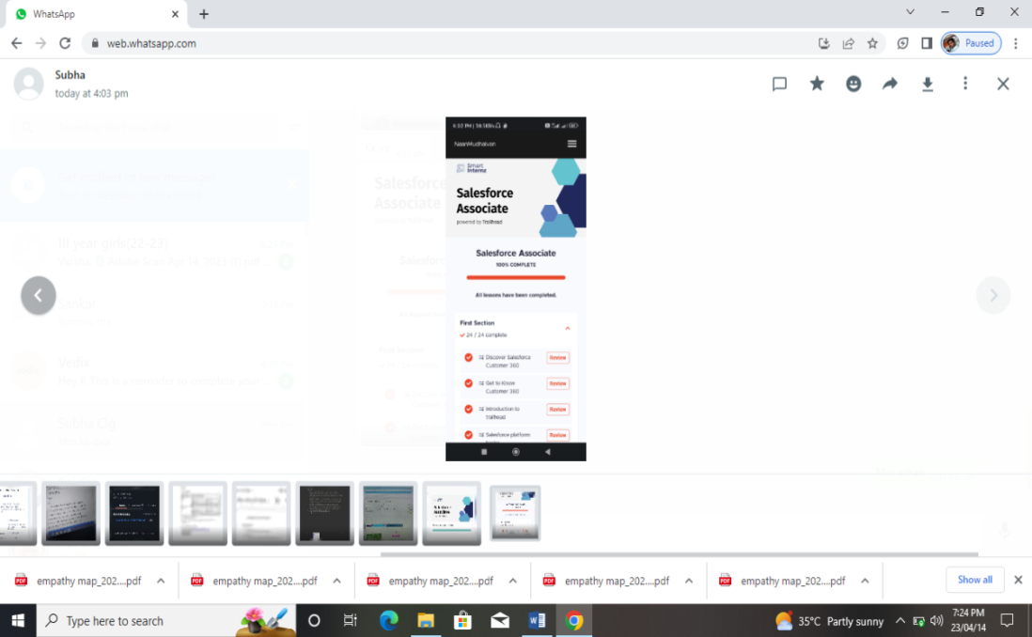

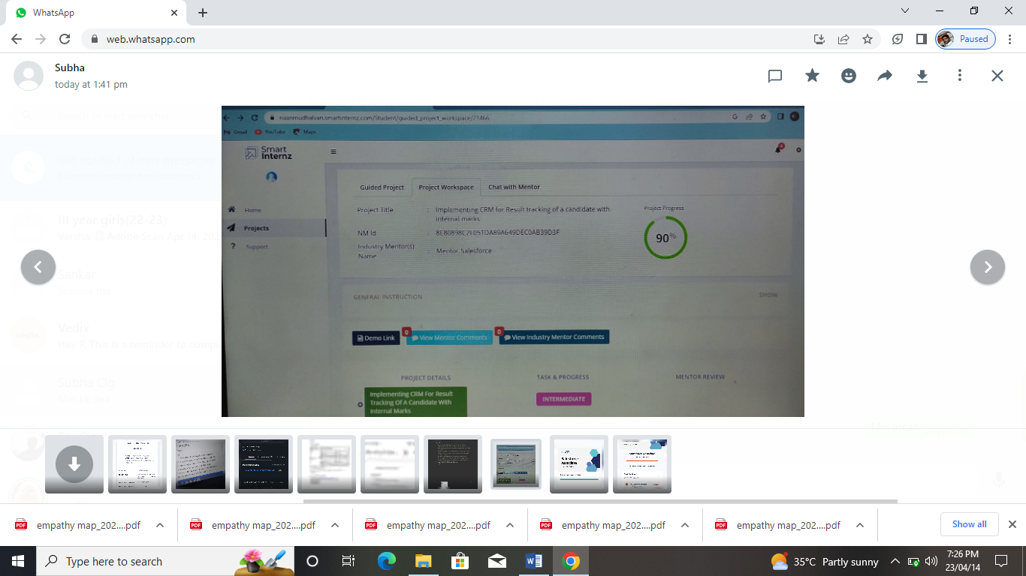

# 4.Trallhead& Profile Public URL

Team Lead –<https://trailblazer.me/id/azeref>

Team Member 1-<https://trailblazer.me/id>

Team Member 2-<https://trailblazer.me/id/nnithyakalyanim>

Team Member 3-<https://trailblazer.me/id/sakthivel137>

# 5. ADVANTAGES & DISADVANTAGE

Implementing CRM for Result tracking of a candidate with internal marks disadvantage

To implement a CRM (Customer Relationship Management) system for result tracking of a candidate with internal marks disadvantage, you can follow these steps:

Define the requirements: First, you need to define the requirements for the CRM system. You should identify what data you need to track, what features you need, and how you will use the data to help the candidate.

Choose a CRM system: Based on your requirements, you should choose a CRM system that fits your needs. There are many CRM systems available in the market, such as Salesforce, HubSpot, Zoho, etc. Choose the one that suits your requirements and budget.

Configure the CRM system: After choosing the CRM system, you need to configure it based on your requirements. You should create custom fields to track the data you need, set up automation workflows to trigger actions based on certain conditions, and create reports to analyze the data.

Add the candidate data: Once the CRM system is configured, you can add the candidate data. You should create a separate record for each candidate and enter their personal information, academic information, and the results they have achieved so far.

Set up automation workflows: To help the candidate with internal marks disadvantage, you can set up automation workflows to trigger actions based on certain conditions. For example, if the candidate's marks fall below a certain threshold, you can set up an email notification to alert the candidate and their advisor to take action.

Analyze the data: You should regularly analyze the data to identify trends, patterns, and areas where the candidate needs help. You can use the reports generated by the CRM system to identify the areas where the candidate is struggling and take action to address those areas.

Provide personalized support: Based on the analysis of the data, you should provide personalized support to the candidate. You can use the CRM system to track the interactions with the candidate, schedule appointments, and follow up on the progress.

# 6. APPLICATIONS

Implementing CRM for Result tracking of a candidate with internal marks applications

To implement a CRM (Customer Relationship Management) system for result tracking of a candidate with internal marks applications, you can follow these steps:

Define the requirements: First, you need to define the requirements for the CRM system. You should identify what data you need to track, what features you need, and how you will use the data to help the candidate with internal marks applications.

Choose a CRM system: Based on your requirements, you should choose a CRM system that fits your needs. There are many CRM systems available in the market, such as Salesforce, HubSpot, Zoho, etc. Choose the one that suits your requirements and budget.

Configure the CRM system: After choosing the CRM system, you need to configure it based on your requirements. You should create custom fields to track the data you need, set up automation workflows to trigger actions based on certain conditions, and create reports to analyze the data.

Add the candidate data: Once the CRM system is configured, you can add the candidate data. You should create a separate record for each candidate and enter their personal information, academic information, and the details of the internal marks application.

Set up automation workflows: To help the candidate with internal marks applications, you can set up automation workflows to trigger actions based on certain conditions. For example, if the candidate submits an application for internal marks, you can set up a workflow to notify the relevant parties and track the progress of the application.

Analyze the data: You should regularly analyze the data to identify trends, patterns, and areas where the candidate needs help. You can use the reports generated by the CRM system to identify the areas where the candidate is struggling and take action to address those areas.

Provide personalized support: Based on the analysis of the data, you should provide personalized support to the candidate. You can use the CRM system to track the interactions with the candidate, schedule appointments, and follow up on the progress of the internal marks application.

# 7. CONCLUSION

Implementing CRM for Result tracking of a candidate with internal marks conclusion

Implementing a CRM system for result tracking of a candidate with internal marks can be an effective way to support the candidate in achieving their academic goals. By tracking and analyzing data related to the candidate's academic performance and internal marks applications, the CRM system can help identify areas where the candidate may need additional support or resources. Automation workflows can also help streamline the process of tracking and managing internal marks applications, allowing for timely notification and follow-up. Ultimately, by providing personalized support and utilizing the insights gained through data analysis, the CRM system can help the candidate overcome the challenges posed by internal marks disadvantage and achieve academic success.

# 8. FUTURE SCOPE

Implementing CRM for Result tracking of a candidate with internal marks future scope

The future scope of implementing a CRM system for result tracking of a candidate with internal marks disadvantage is vast. Here are a few potential areas of growth:

Personalized Learning: By analyzing the candidate's data, a CRM system can identify areas where the candidate is struggling and provide personalized learning resources to address those areas.

Collaboration: A CRM system can facilitate collaboration among advisors, instructors, and other stakeholders to help the candidate with internal marks disadvantage. It can help ensure that everyone is aware of the candidate's progress and can work together to support them.

Predictive Analytics: A CRM system can use predictive analytics to forecast the candidate's academic performance based on historical data, allowing for more proactive intervention and support.

Gamification: A CRM system can gamify the learning process, making it more engaging and motivating for the candidate. This can help them stay motivated and achieve their academic goals.

Integration with other systems: A CRM system can be integrated with other academic systems, such as Learning Management Systems (LMS), to provide a seamless experience for the candidate and ensure that data is up-to-date and accurate.